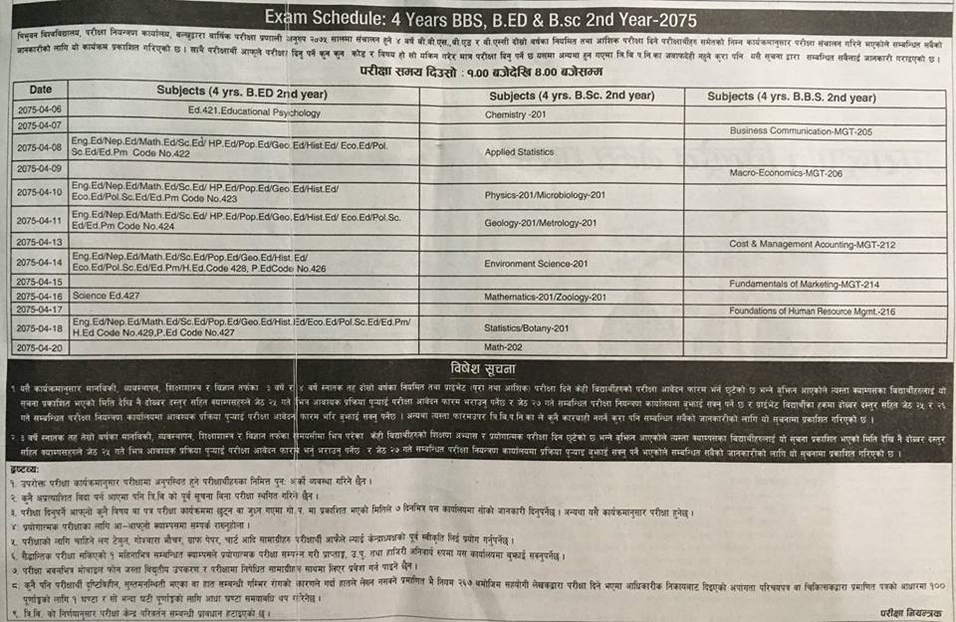
EXAM SCHEDULE - 4 YEARS BBSB.B.ED & B.SC 2ND YEARS -2075

